**PABNA UNIVERSITY OF SCIENCE AND TECHNOLOGY**

Department of Information and Communication Technology

Faculty of Engineering and Technology



**DECLARATION**

This is to certified that I have done this project and it has not been submitted elsewhere for the award of ant degree or diploma.

Author:

…….……………………..

Md. Sidul Islam Sozol

Roll: 180608

Reg. No. : 1065291

**Department of Information and Communication Engineering**

**Pabna University of Science and Technology**

**TABLE OF CONTENTS**

Name Pages

Acknowledgement……………………………………………………………………..……4

Abstract………………………………………………………………………….……….….5

**CHAPTER 1**

1.1 Introduction…………………………………………………………………………..….6

**CHAPTER 2 : LIST OF COMPONENT**

2.1 Resistor…………………………………………………………………………………..7

2.2 Potentiometer………………………………………………………………………...….8

2.3 Crystal oscillator…………………………………………………………………......….9

2.4 Capacitor………………………………………………………………………….....…10

2.5 Diode……………………………………………………………………………..…….11

2.6 Transistor…………………………………………………………………………..…..12

2.6.1 Why transistors are important ?…………………………………………...…13

2.6.2 Parts of transistor………………………………………………………….... 14

2.6.3 Types of transistor…………………………………………………........ 15-16

2.7 Led……………………………………………………………………………….….... 16

2.7.1 What is LED……………………………………………………………..…. 16

2.7.2 LED Symbol………………………………………………………………... 17

2.8 Push Button………………………………………………………………………….....17

2.8.1 What is push button switch ?………………………………………………...17

2.8.2 What does push button switch work ………………………………………..18

2.8.3 Types of push button……………………………………………………...…18

2.8.4 Push nutton switch applications………………………………………….….18

2.9 Relay……………………………………………………………………………..........18

2.9.1 what is relay………………………………………………………….…..….19

2.9.2 Elements of mechanical relay………………………………………….…..20

2.9.3 How a relay works………………………………………………………....21

2.9.4 Types of relay……………………………………………………………...21

2.9.5 Applications of relay………………………………………………………22

2.10 Lcd…………………………………………………………………………………22

2.10.1 What is the lcd (16 x 2)…………………………………………………..22

2.10.2 Pinout of lcd (16 x 2)…………………………………………………….22

2.10.3 Features of lcd……………………………………………………………23

2.10.4 Register of lcd……………………………………………………………23

2.10.5 ( 16 x 2 ) lcd command…………………………………………………..24

2.11 LM35 Temperature Sensor…………………………………………………….…..25

2.11.1 What is LM35…………………………………………………………....25

2.11.2 Pinout of LM35…………………………………………………………..25

#### 2.11.3 Features of LM35 Temperature sensor ………………………………….26

2.12 Microcontroller…………………………………………………………………………..…27

2.12.1 What is Microcontroller………………………………………………………….27

2.12.2 PIC Microcontroller……………………………………………………………..28

2.12.3 PIC16F877A Microcontroller…………………………………………………...29

2.12.4 Pinout of PIC16F877A Microcontroller………………………………………...30

2.12.5 Feature of PIC16F877A Microcontroller…………………………………….….31

**CHAPTER 3 : DISCRIPTION OF THE SYSTEM**

3.1 Schematric description…………………………………………………………..33-35

3.2 Circuit diagram………………………………………………………………………35

3.3 Algorithm (pseudo code)………………………………………………………....36-37

3.4 Physical connection arrangement……………………………………………………38

**CHAPTER 4 : RESULT AND DISCUSSION**

4.1 Conclution…………………………………………………………………………39

4.2 Recommendation……………………………………………………………… …39

4.3 Future Work……………………………………………………………………….40

**ACKNOWLEDGEMENT**

First of all, I express my whole hearted gratitude to almighty Allah for preparing my project report successfully. I would like to convey my sincere and deep sense of gratitude to all who have helped this project. I would like to express my deepest sense of gratitude and respective to my supervisor Tarun Debnath , Lecturer, Department of Information and Communication Engineering , Pabna University of Science and Technology for this suggestion to select this topic and great supervisory advice. I am specially honor to my supervisor for his charming guidance , enthusiastic advice and other fruitful helps throughout the duration of this project.

I am especially pleased and thankful to him for allowing me to work under his supervision.

I would also like to thank to the department of Information and Communication Engineering, Pabna University of Science and Technology, Pabna, for providing sufficient computer, software, hardware, electrical and electronics facilities and other logistic supports to carry out my project.I would also like to thank to my friends, senior - junior brother for motivating and encouraging me to successfully finished of my project.

Last but not least, I would like to thank my parents for their blessing and love as well as my brothers and sisters for their constant support and encouragement.

**ABSTRACT**

The objective of the project is to control the objects mainly Lights and fans with respect to the poultry farm temperature. We use the LM35 temperature sensor for receiving the farm temperature. The main controller device I used that is microcontroller. For switching device is the mechanical relay. I investigated that most of the poultry in the farms are suffer because of temperature. In this case, many of the farm is destroyed without controlling temperature. I want to solve this nephropathy problem of the poultry farm. And help to grow up to the owners economy.

**CHAPTER 1**

**INTRODUCTION**

The aim of the project is control the objects such as light, fans, motor, Alarm e.t.c with respect to room temperature of a poultry farm. In this project, we need to read temperature of the farm so that we use temperature sensor such as LM35, DS18B20, DHT11 etc. We use Microcontroller as a main decision device. We will use PIC16F877A in this project. For selecting threshold value , we use two button. All the information will be showed on the LCD display. Relay is used as a switching device.

At present time, world temperature is increased day by day. So many agricultural farm and farm is destroyed for increasing temperature. It is high time to control temperature of farm which is so sensitive against temperature. The poultry farm is one of this farm. The poultry is not comfortable for any temperature. If the temperature is move up from 40°C, the  poultry is started to suffer and after a mean time, the poultry will be started heat stroke. As a same way, when the temperature is move down from 18°C , the  poultry is started to suffer and after a mean time, the poultry will be started cold stroke.

So, the owner of the poultry farm is destroyed by temperature. For this reason, we will develop a system that will control the farm temperature.

**CHAPTER – 2**

**LIST OF COMPONENT**

**2.1 RESISTOR**

A **resistor** is a [passive](https://en.wikipedia.org/wiki/Passivity_(engineering)) [two terminal](https://en.wikipedia.org/wiki/Terminal_(electronics)) [electrical component](https://en.wikipedia.org/wiki/Electronic_component) that implements [electrical resistan-](https://en.wikipedia.org/wiki/Electrical_resistance)

ce. In electronic circuits, resistors are used to reduce current flow, adjust signal levels, to [divide voltages](https://en.wikipedia.org/wiki/Voltage_divider), [bias](https://en.wikipedia.org/wiki/Biasing) active elements, and terminate [transmission lines](https://en.wikipedia.org/wiki/Transmission_line), among other uses. High-power resistors that can dissipate many [watts](https://en.wikipedia.org/wiki/Watt) of electrical power as heat may be used as part of motor controls, in power distribution systems, or as test loads for [generators](https://en.wikipedia.org/wiki/Electric_generator). Fixed resistors have resistances that only change slightly with temperature, time or operating voltage. Variable resistors can be used to adjust circuit elements (such as a volume control or a lamp dimmer), or as sensing devices for heat, light, humidity, force, or chemical activity.

Resistors are common elements of [electrical networks](https://en.wikipedia.org/wiki/Electrical_network) and [electronic circuits](https://en.wikipedia.org/wiki/Electronic_circuit) and are ubiquitous in [electronic equipment](https://en.wikipedia.org/wiki/Electronics). Practical resistors as discrete components can be composed of various compounds and forms. Resistors are also implemented within [integrated circuits](https://en.wikipedia.org/wiki/Integrated_circuits). The electrical function of a resistor is specified by its resistance: common commercial resistors are manufactured over a range of more than nine [orders of magnitude](https://en.wikipedia.org/wiki/Orders_of_magnitude).

The nominal value of the resistance falls within the [manufacturing tolerance](https://en.wikipedia.org/wiki/Engineering_tolerance#Electrical_component_tolerance), indicated on the component.

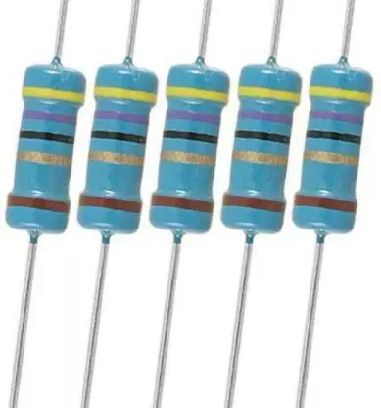

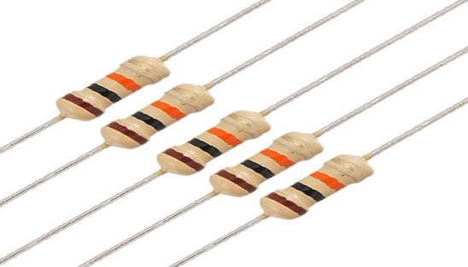

10Kohm 47ohm

Fig- 2.1 : Resistor [ <https://www.aboutmechanics.com/> ]

**2.2 POTENTIOMETER**

A **potentiometer** is a three-[terminal](https://en.wikipedia.org/wiki/Terminal_(electronics)) [resistor](https://en.wikipedia.org/wiki/Resistor) with a sliding or rotating contact that forms an adjustable [voltage divider](https://en.wikipedia.org/wiki/Voltage_divider). If only two terminals are used, one end and the wiper, it acts as a **variable resistor** or **rheostat**.

The measuring instrument called a [potentiometer](https://en.wikipedia.org/wiki/Potentiometer_(measuring_instrument)) is essentially a [voltage divider](https://en.wikipedia.org/wiki/Voltage_divider) used for measuring [electric potential](https://en.wikipedia.org/wiki/Electric_potential) (voltage); the component is an implementation of the same principle, hence its name.

Potentiometers are commonly used to control electrical devices such as volume controls on audio equipment. Potentiometers operated by a mechanism can be used as position [transducers](https://en.wikipedia.org/wiki/Transducer), for example, in a [joystick](https://en.wikipedia.org/wiki/Joystick). Potentiometers are rarely used to directly control significant power (more than a [watt](https://en.wikipedia.org/wiki/Watt)), since the power dissipated in the potentiometer would be comparable to the power in the controlled load.

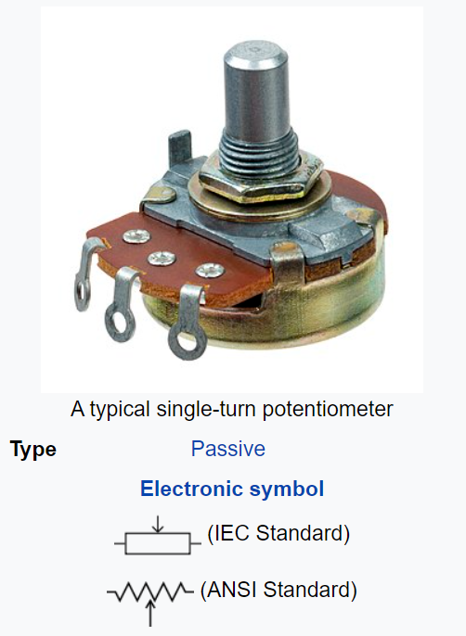

Fig- 2.2 : Potentiometer [ <https://en.wikipedia.org/wiki/Potentiometer> ]

**2.3 CRYSTAL OSCILLATOR**

A **crystal oscillator** is an [electronic oscillator](https://en.wikipedia.org/wiki/Electronic_oscillator) [circuit](https://en.wikipedia.org/wiki/Electrical_circuit) that uses a piezoelectric crystal as a frequen-cy as a [selective element](https://en.wikipedia.org/wiki/Frequency_selective_surface). The oscillator frequency is often used to keep track of time, as in [quartz wristwatches](https://en.wikipedia.org/wiki/Quartz_clock), to provide a stable [clock signal](https://en.wikipedia.org/wiki/Clock_signal) for [digital](https://en.wikipedia.org/wiki/Digital_data) [integrated circuits](https://en.wikipedia.org/wiki/Integrated_circuit), and to stabilize frequencies for [radio transmitters](https://en.wikipedia.org/wiki/Radio_transmitter) and [receivers](https://en.wikipedia.org/wiki/Radio_receiver). The most common type of piezoelectric resonator used is a [quartz](https://en.wikipedia.org/wiki/Quartz) crystal, so oscillator circuits incorporating them became known as crystal oscillators. However, other piezoelectricity materials including [polycrystalline](https://en.wikipedia.org/wiki/Polycrystalline) ceramics are used in similar circuits.

A crystal oscillator relies on the slight change in shape of a quartz crystal under an [electric field](https://en.wikipedia.org/wiki/Electric_field), a property known as [electrostriction](https://en.wikipedia.org/wiki/Electrostriction) or inverse piezoelectricity. A voltage applied to the electrodes-on the crystal causes it to change shape; when the voltage is removed, the crystal generates a small voltage as it elastically returns to its original shape. The quartz oscillates at a stable resonant frequency, behaving like an [RLC circuit](https://en.wikipedia.org/wiki/RLC_circuit), but with a much higher [Q factor](https://en.wikipedia.org/wiki/Q_factor) (less energy loss on each cycle of oscillation). Once a quartz crystal is adjusted to a particular frequency (which is affected by the mass of electrodes attached to the crystal, the orientation of the crystal, temperature and other factors), it maintains that frequency with high stability.

Quartz crystals are manufactured for frequencies from a few tens of [kilohertz](https://en.wikipedia.org/wiki/Kilohertz) to hundreds of megahertz. As of 2003, around two billion crystals are manufactured annually. Most are used for consumer devices such as [wristwatches](https://en.wikipedia.org/wiki/Wristwatch), [clocks](https://en.wikipedia.org/wiki/Clock), [radios](https://en.wikipedia.org/wiki/Radio), [computers](https://en.wikipedia.org/wiki/Computer), and [cellphones](https://en.wikipedia.org/wiki/Cellphone). However in applications where small size and weight is needed crystals can be replaced by [thin-film bulk acoustic resonators](https://en.wikipedia.org/wiki/Thin-film_bulk_acoustic_resonator), specifically if high frequency (more than roughly 1.5 GHz) resonance is needed.

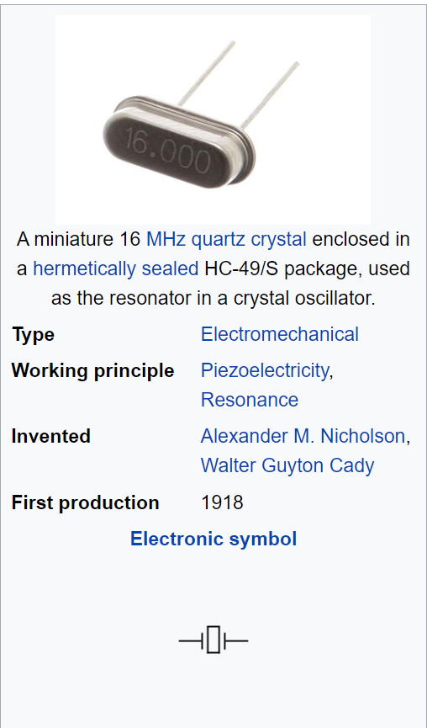

Fig- 2.3 : Quartz crystal [ <https://en.wikipedia.org/wiki/Crystal_oscillator> ]

**2.4 CAPACITOR**

A capacitor is a device that stores electrical energy in an [electric field](https://en.wikipedia.org/wiki/Electric_field). It is a passive electronic component with two [terminals](https://en.wikipedia.org/wiki/Terminal_(electronics)).

The effect of a capacitor is known as [capacitance](https://en.wikipedia.org/wiki/Capacitance). While some capacitance exists between any two electrical conductors in proximity in a [circuit](https://en.wikipedia.org/wiki/Electric_circuit), a capacitor is a component designed to add capacitance to a circuit. The capacitor was originally known as a condenser or condensator, This name and its [cognates](https://en.wikipedia.org/wiki/Cognate) are still [widely used in many languages](https://en.wiktionary.org/wiki/capacitor#translations), but rarely in English, one notable exception being [condenser microphones](https://en.wikipedia.org/wiki/Condenser_microphones), also called capacitor microphones.

The physical form and construction of practical capacitors vary widely and many [types of capacitor](https://en.wikipedia.org/wiki/Capacitor_types) are in common use. Most capacitors contain at least two [electrical conductors](https://en.wikipedia.org/wiki/Electrical_conductor) often in the form of metallic plates or surfaces separated by a [dielectric](https://en.wikipedia.org/wiki/Dielectric) medium. A conductor may be a foil, thin film, sintered bead of metal, or an [electrolyte](https://en.wikipedia.org/wiki/Electrolyte). Materials commonly used as dielectrics include [glass](https://en.wikipedia.org/wiki/Glass), [ceramic](https://en.wikipedia.org/wiki/Ceramic), [plastic film](https://en.wikipedia.org/wiki/Plastic_film), [paper](https://en.wikipedia.org/wiki/Paper), [mica](https://en.wikipedia.org/wiki/Mica), air, and [oxide layers](https://en.wikipedia.org/wiki/Oxide). Capacitors are widely used as parts of [electrical circuits](https://en.wikipedia.org/wiki/Electrical_circuit) in many common electrical devices. Unlike a [resistor](https://en.wikipedia.org/wiki/Resistor), an ideal capacitor does not dissipate energy, although real-life capacitors do dissipate a small amount When an [electric potential](https://en.wikipedia.org/wiki/Electric_potential) difference is applied across the terminals of a capacitor, for example when a capacitor is connected across a battery, an [electric field](https://en.wikipedia.org/wiki/Electric_field) develops across the dielectric, causing a net positive [charge](https://en.wikipedia.org/wiki/Electric_charge) to collect on one plate and net negative charge to collect on the other plate. No current actually flows through the dielectric. If the condition is maintained sufficiently long, the current through the source circuit ceases. If a time-varying voltage is applied across the leads of the capacitor, the source experiences an ongoing current due to the charging and discharging cycles of the capacitor.

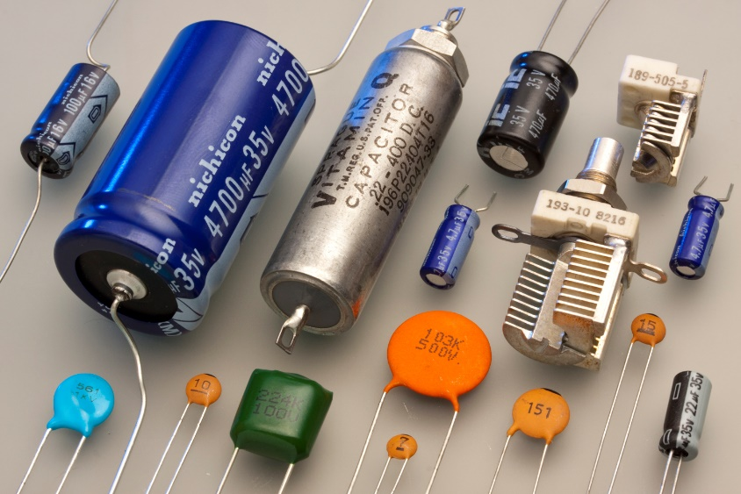

Fig- 2.4 : Capacitor [ <https://en.wikipedia.org/wiki/Capacitor> ]

**2.5 DIODE**

A **diode** is a two-[terminal](https://en.wikipedia.org/wiki/Terminal_(electronics)) [electronic component](https://en.wikipedia.org/wiki/Electronic_component) that conducts [current](https://en.wikipedia.org/wiki/Electric_current) primarily in one direction (asymmetric [conductance](https://en.wikipedia.org/wiki/Electrical_conductance)); it has low (ideally zero) [resistance](https://en.wikipedia.org/wiki/Electrical_resistance_and_conductance) in one direction, and high (ideally infinite) [resistance](https://en.wikipedia.org/wiki/Electrical_resistance_and_conductance) in the other.

A diode [vacuum tube](https://en.wikipedia.org/wiki/Vacuum_tube) or thermionic diode is a vacuum tube with two [electrodes](https://en.wikipedia.org/wiki/Electrode), a heate-d [cathode](https://en.wikipedia.org/wiki/Cathode) and a [plate](https://en.wikipedia.org/wiki/Plate_electrode), in which electrons can flow in only one direction, from cathode to plate.

A semiconductor diode, the most commonly used type today, is a [crystalline](https://en.wikipedia.org/wiki/Crystallinity) piece of [semiconductor](https://en.wikipedia.org/wiki/Semiconductor) material with a [p–n junction](https://en.wikipedia.org/wiki/P%E2%80%93n_junction) connected to two electrical terminals. Semiconductor diodes were the first [semiconductor electronic devices](https://en.wikipedia.org/wiki/Semiconductor_device). The discovery of asymmetric electrical conduction across the contact between a crystalline mineral and a metal was made by German physicist [Ferdinand Braun](https://en.wikipedia.org/wiki/Ferdinand_Braun) in 1874. Today, most diodes are made of [silicon](https://en.wikipedia.org/wiki/Silicon), but other semiconducting materials such as [gallium arsenide](https://en.wikipedia.org/wiki/Gallium_arsenide) and [germanium](https://en.wikipedia.org/wiki/Germanium) are also used.

Among many uses, diodes are found in [rectifiers](https://en.wikipedia.org/wiki/Rectifiers) to convert AC power to DC, [demodulation](https://en.wikipedia.org/wiki/Demodulation) in radio receivers, and can even be used as [temperature sensors](https://en.wikipedia.org/wiki/Temperature_sensor). A common variant of a diode is a [light emitting diode](https://en.wikipedia.org/wiki/Light_emitting_diode), which is used as [electric lighting](https://en.wikipedia.org/wiki/Electric_lighting) and status indicators on electronic devices. Diodes may be combined with other components to form [logic gates](https://en.wikipedia.org/wiki/Logic_gate).

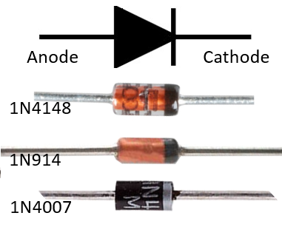

Fig- 2.5 : Diodes [ <https://www.electrical4u.com/diodes/> ]

**2.6: TRANSISTOR**

A **transistor** is a [semiconductor device](https://en.wikipedia.org/wiki/Semiconductor_device) used to [amplify](https://en.wikipedia.org/wiki/Electronic_amplifier) or [switch](https://en.wikipedia.org/wiki/Electronic_switch) electrical signals and [power](https://en.wikipedia.org/wiki/Electrical_power). The transistor is one of the basic building blocks of modern [electronics](https://en.wikipedia.org/wiki/Electronics). It is composed of [semiconductor material](https://en.wikipedia.org/wiki/Semiconductor_material), usually with at least three [terminals](https://en.wikipedia.org/wiki/Terminal_(electronics)) for connection to an electronic circuit. A [voltage](https://en.wikipedia.org/wiki/Voltage) or [current](https://en.wikipedia.org/wiki/Electric_current) applied to one pair of the transistor's terminals controls the current through another pair of terminals. Because the controlled (output) power can be higher than the controlling (input) power, a transistor can amplify a signal. Some transistors are packaged individually, but many more are found embedded in [integrated circuits](https://en.wikipedia.org/wiki/Integrated_circuit).

[Austro-Hungarian](https://en.wikipedia.org/wiki/Austria-Hungary) [physicist](https://en.wikipedia.org/wiki/Physicist) [Julius Edgar Lilienfeld](https://en.wikipedia.org/wiki/Julius_Edgar_Lilienfeld) proposed the concept of a [field-effect transistor](https://en.wikipedia.org/wiki/Field-effect_transistor) in 1926, but it was not possible to actually construct a working device at that time. The first working device to be built was a [point-contact transistor](https://en.wikipedia.org/wiki/Point-contact_transistor) invented in 1947 by American physicists [John Bardeen](https://en.wikipedia.org/wiki/John_Bardeen) and [Walter Brattain](https://en.wikipedia.org/wiki/Walter_Brattain) while working under [William Shockley](https://en.wikipedia.org/wiki/William_Shockley) at [Bell Labs](https://en.wikipedia.org/wiki/Bell_Labs). The three shared the 1956 [Nobel Prize in Physics](https://en.wikipedia.org/wiki/Nobel_Prize_in_Physics) for their achievement. The most widely used type of transistor is the [metal–oxide–semiconductor field-effect transistor](https://en.wikipedia.org/wiki/Metal%E2%80%93oxide%E2%80%93semiconductor_field-effect_transistor) (MOSFET), which was invented by [Mohamed Atalla](https://en.wikipedia.org/wiki/Mohamed_Atalla) and [Dawon Kahng](https://en.wikipedia.org/wiki/Dawon_Kahng" \o "Dawon Kahng) at Bell Labs in 1959. Transistors revolutionized the field of electronics, and paved the way for smaller and cheaper [radios](https://en.wikipedia.org/wiki/Radio), [calculators](https://en.wikipedia.org/wiki/Calculator), and [computers](https://en.wikipedia.org/wiki/Computer), among other things.

Most transistors are made from very pure [silicon](https://en.wikipedia.org/wiki/Silicon), and some from [germanium](https://en.wikipedia.org/wiki/Germanium), but certain other semiconductor materials are sometimes used. A transistor may have only one kind of charge carrier, in a field-effect transistor, or may have two kinds of charge carriers in [bipolar junction transistor](https://en.wikipedia.org/wiki/Bipolar_junction_transistor) devices. Compared with the [vacuum tube](https://en.wikipedia.org/wiki/Vacuum_tube), transistors are generally smaller and require less power to operate. Certain vacuum tubes have advantages over transistors at very high operating frequencies or high operating voltages. Many types of transistors are made to standardized specifications by multiple manufacturers.

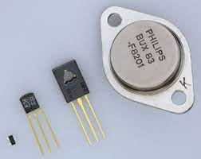

### Fig- 2.6 : Transistor [ <https://en.wikipedia.org/wiki/Transistor> ]

### 

### 2.6.1: Why transistors are important

On its own, a transistor has only one circuit element. In small quantities, transistors are used to create simple electronic switches. They are the basic elements in integrated circuits ([ICs](https://www.techtarget.com/whatis/definition/integrated-circuit-IC)), which consist of a large number of transistors interconnected with circuitry and baked into a single silicon [microchip](https://www.techtarget.com/whatis/definition/microchip).

In large numbers, transistors are used to create [microprocessors](https://www.techtarget.com/whatis/definition/microprocessor-logic-chip) where millions of transistors are embedded into a single IC. They also drive computer memory chips and memory storage devices for MP3 players, smartphones, cameras and electronic games. Transistors are deeply embedded in nearly all ICs, which are part of every electronic device.

Transistors are also used for low-frequency, high-power applications, such as power-supply inverters that convert alternating current into direct current. Additionally, transistors are used in high-frequency applications, such as the oscillator circuits used to generate radio signals.

### 2.6.2 : Parts of a transistor

### A transistor is like a set of two diodes with their [cathodes](https://www.techtarget.com/whatis/definition/cathode) or [anodes](https://www.techtarget.com/whatis/definition/anode) tied together. It has three terminals that carry electrical current and help make a connection to external circuits.

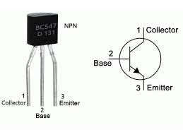

Fig- 2.7 : Parts of Transistor [ <https://shoptransmitter.com/> ]

1. the emitter, also known as the transistor's negative lead.
2. the base, which is the terminal that activates the transistor, and
3. the collector, which is the transistor's positive lead.

Let's consider an NPN transistor to understand these terminals. In this configuration, the p-type silicon (base) is sandwiched between two slabs of n-type silicon (the emitter and collector).

The emitter -- indicated by the letter E -- is moderately sized and heavily doped as its primary function is to supply numerous majority carriers to support the flow of electricity. It's called the emitter since it emits electrons.

The base -- indicated by the letter B -- is the center terminal between the emitter and the collector. It is thin and lightly doped. Its main purpose is to pass the carriers from the emitter to the collector.

The collector -- indicated by the letter C -- collects carriers sent by the emitter via the base. It's moderately doped and larger than both the emitter and base.

### 2.6.3: Types of transistor

### Transistors are classified into two major types:

* Bipolar junction transistor ([BJT](https://www.techtarget.com/whatis/definition/bipolar-transistor))
* Field-effect transistor ([FET](https://www.techtarget.com/whatis/definition/field-effect-transistor-FET))

A BJT is one of the most common types of transistors, and can be either NPN or PNP. This means a BJT consists of three terminals: the emitter, the base and the collector. By joining these three layers, a BJT can amplify an electrical signal or switch the current on or off. Two kinds of electrical charge -- electrons and holes -- are involved in creating a current flow. In its normal operation, the BJT's base-emitter junction is forward-biased with a very small emitter [resistance](https://www.techtarget.com/whatis/definition/resistance), while the base-collector junction is reverse-biased with a large resistance. In a PNP-type BJT, conduction happens through holes or the absence of electrons. The collector current is slightly less than the emitter current. Changes in the latter affect the former. The base controls the current flow from the emitter to the collector. In this case, the emitter emits holes, which are then collected by the collector. In an NPN-type BJT, electrons pass from the emitter to the base and are collected by the collector. When this happens, conventional current flows from the collector to the emitter.

A field-effect transistor (FET) also has three terminals -- source, drain and gate -- which are analogous to BJT's emitter, collector and base, respectively. In the FET, the n-type and p-type silicon layers are arranged differently from those of the BJT. They are also coated with layers of metal and oxide to create the metal-oxide semiconductor field effect transistor ([MOSFET](https://www.techtarget.com/whatis/definition/MOSFET-metal-oxide-semiconductor-field-effect-transistor)). In the FET, field-effect refers to an effect that enables the flow of current and switches the transistor on. Electrons can't flow from the n-type source to the drain because the p-type gate between them contains holes. But attaching a positive voltage to the gate creates an electric field that enables electrons to flow from the source to the drain. This creates the field effect, which facilitates the flow of current in the FET. FETs are commonly used in low-noise amplifiers, buffer amplifiers and analog switches. The metal-semiconductor field-effect transistor (MESFET) is commonly used for high-frequency applications, such as microwave circuits.

**2.7: LED**

## **2.7.1: What is LED?**

A light-emitting diode (LED) is a semiconductor device that emits light when an electric current flows through it. When current passes through an LED, the electrons recombine with holes emitting light in the process. LEDs allow the current to flow in the forward direction and blocks the current in the reverse direction.

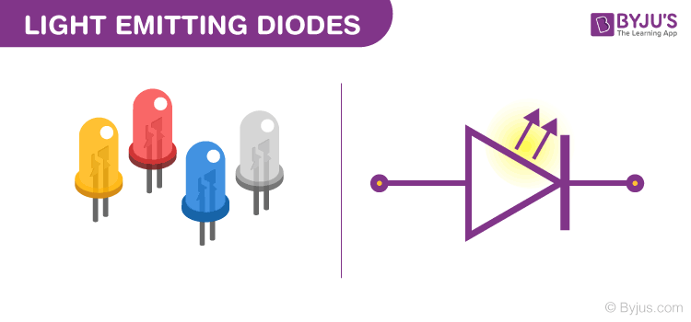

Fig- 2.8 : LED [ <https://byjus.com/physics/light-emitting-diode/> ]

Light-emitting diodes are heavily doped p-n junctions. Based on the semiconductor material used and the amount of doping, an LED will emit a coloured light at a particular spectral wavelength when forward biased. As shown in the figure, an LED is encapsulated with a transparent cover so that emitted light can come out.

## **2.7.2: LED Symbol**

The LED symbol is the [standard symbol for a diode](https://byjus.com/physics/diodes/), with the addition of two small arrows denoting the emission of light.

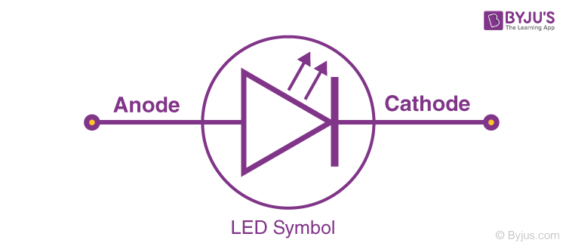

Fig- 2.9 : LED Symbol [ <https://byjus.com/physics/light-emitting-diode/> ]

# **2.8: PUSH BUTTON**

### 2.8.1: What is a Push Button Switch?

### A [push button switch](https://www.cuidevices.com/catalog/switches/push-button-switches) is a mechanical device used to control an electrical circuit in which the operator manually presses a button to actuate an internal switching mechanism. They come in a variety of shapes, sizes, and configurations, depending on the design requirements.

Fig- 2.11: Push Button [ [https://shopee.com.](https://shopee.com.my/Push-Button-12*12mm-With-Button-Cap-Random-Blue-Red-Tact-Switch-i.33091591.2219533304)]

**2.8.2: How Does a Push Button Switch Operate ?**

Push button switches rely on a simple in-out actuation mechanism. They can be employed to break (off) or initiate (on) a circuit. Alternatively, they can provide an input for the user interface of a piece of equipment or start/stop a particular function.

Push button switches may be categorized as being either momentary (where the switch function only continues for as long as the operator is pushing the button) or maintained (where the switch function stays latched in that status after it has been actuated).

### 2.8.3: Types of Push Button Switches

### 1. Single pole-single throw (SPST)

### 2.  Single pole-double throw (SPDT)

### 3. Double pole-single throw (DPST)

### 4. Double pole-double throw (DPDT)

### 2.8.4: Push Button Applications

### Push button switches have been around for quite some time and might be most well-recognized for their use in classic arcade machines. However, their use is widespread in various applications, such as vending machines, portable equipment, household appliances, power tools, and countless other consumer electronics and industrial controls.

### 2.9: RELAY

## **2.9.1: What is a Relay?**

A Relay is a simple electromechanical switch. While we use normal switches to close or open a circuit manually, a [Relay](https://www.electronicshub.org/relay-wiring-diagram/) is also a switch that connects or disconnects two circuits. But instead of a manual operation, a relay uses an electrical signal to control an electromagnet, which in turn connects or disconnects another circuit.

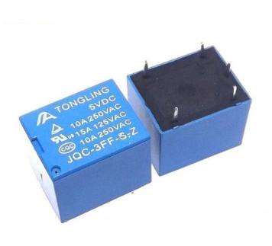

Fig- 2.12: Relay [ <https://electronation.pk/product/relay-6v-5-pin/> ]

Relays can be of different types like electromechanical, [solid state](https://www.electronicshub.org/solid-state-relay/). Electromechanical relays are frequently used. Let us see the internal parts of this relay before knowing about it working. Although many different types of relay were present, their working is same.

**2.9.2: Elements of Mechanical Relay**

Every electromechanical relay consists of an consists of an

1. Electromagnet
2. Mechanically movable contact
3. Switching points and
4. Spring

Electromagnet is constructed by wounding a copper coil on a metal core. The two ends of the coil are connected to two pins of the relay as shown. These two are used as DC supply pins.



Fig- 2.13 : Element of Mechanical Relay [ [https://www.electronicshub.org/](https://www.electronicshub.org/what-is-relay-and-how-it-works/) ]

Generally, two more contacts will be present, called as switching points to connect high ampere load. Another contact called common contact is present in order to connect the switching points. These contacts are named as normally open (NO), normally closed (NC) and common (COM) contacts. We can use a Relay either in a AC circuit or a DC Circuit. In case of AC relays, for every current zero position, the relay coil gets demagnetized and hence there would be a chance of continues breaking of the circuit.

**2.9.3: How a Relay Works?**

The following animation shows a simplified working of a relay.

Fig- 2.14 : Working procedure of mechanical Relay [<https://www.electronicshub.org/> ]

* Relay works on the principle of electromagnetic induction.
* When the electromagnet is applied with some current, it induces a magnetic field around it.
* Above image shows working of the relay. A switch is used to apply DC current to the load.
* In the relay, Copper coil and the iron core acts as electromagnet.
* When the coil is applied with DC current, it starts attracting the contact as shown. This is called energizing of relay.
* When the supply is removed it retrieves back to the original position. This is called De energizing of relay.

## **2.9.4: Types of Relays**

There are many types of relay. They are Electromagnetic, Latching, Electronic, Non-Latching, Reed, High-Voltage, Small Signal, Time Delay, Multi-Dimensional, Thermal, Differential, Distance, Automotive, Frequency, Polarized, Rotary, Sequence, Moving Coil, Buchholz, Safety, Supervision, Ground Fault etc.

## **2.9.5: Relay Applications**

Relays are used to protect the electrical system and to minimize the damage to the equipment connected in the system due to over currents/voltages. The relay is used for the purpose of protection of the equipment connected with it. These are used to control the high voltage circuit with low voltage signal in applications audio amplifiers and some types of modems. These are used to control a high current circuit by a low current signal in the applications like starter solenoid in automobile. These can detect and isolate the faults that occurred in power transmission and distribution system. Typical application areas of the relays include

* Lighting control systems
* Telecommunication
* Industrial process controllers
* Traffic control
* Motor drives control
* Protection systems of electrical power system
* Computer interfaces
* Automotive
* Home appliances

**2.10: LCD**

## **2.10.1: What is the LCD (16×2) ?**

The term [LCD stands for liquid crystal display](https://www.elprocus.com/difference-alphanumeric-display-and-customized-lcd/). It is one kind of electronic display module used in an extensive range of applications like various circuits & devices like mobile phones, calculators, computers, TV sets, etc. These displays are mainly preferred for multi-segment [light-emitting diodes](https://www.elprocus.com/light-emitting-diode-led-working-application/) and seven segments. The main benefits of using this module are inexpensive; simply programmable, animations, and there are no limitations for displaying custom characters, special and even animations, etc.

### 2.10.2: LCD ( 16×2 ) Pin Diagram

* Pin1 (Ground/Source Pin): This is a GND pin of display, used to connect the GND terminal of the microcontroller unit or power source.
* Pin2 (VCC/Source Pin): This is the voltage supply pin of the display, used to connect the supply pin of the power source.
* Pin3 (V0/VEE/Control Pin): This pin regulates the difference of the display, used to connect a changeable POT that can supply 0 to 5V.
* 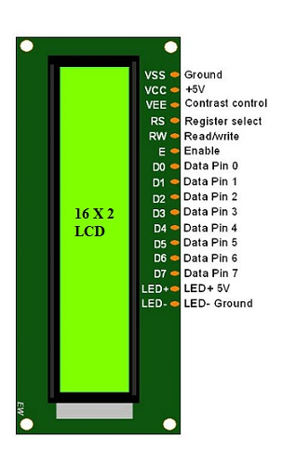Pin4 (Register Select/Control Pin): This pin toggles among command or data register, used to connect a microcontroller unit pin and obtains either 0 or 1(0 = data mode, and 1 = command mode).

Fig- 2.16 : LCD 16 X 2 pin diagram [ [https://www.elprocus.com/](https://www.elprocus.com/lcd-16x2-pin-configuration-and-its-working/)  ]

* Pin5 (Read/Write/Control Pin): This pin toggles the display among the read or writes operation, and it is connected to a microcontroller unit pin to get either 0 or 1 (0 = Write Operation, and 1 = Read Operation).
* Pin 6 (Enable/Control Pin): This pin should be held high to execute Read/Write process, and it is connected to the microcontroller unit & constantly held high.
* Pins 7-14 (Data Pins): These pins are used to send data to the display. These pins are connected in two-wire modes like 4-wire mode and 8-wire mode. In 4-wire mode, only four pins are connected to the microcontroller unit like 0 to 3, whereas in 8-wire mode, 8-pins are connected to microcontroller unit like 0 to 7.
* Pin15 (+ve pin of the LED): This pin is connected to +5V
* Pin 16 (-ve pin of the LED): This pin is connected to GND.

### 2.10.3: Features of LCD16x2

The features of this LCD mainly include the following.

* The operating voltage of this LCD is 4.7V-5.3V
* It includes two rows where each row can produce 16-characters.
* The utilization of current is 1mA with no backlight
* Every character can be built with a 5×8 pixel box
* The alphanumeric LCDs alphabets & numbers
* Is display can work on two modes like 4-bit & 8-bit
* These are obtainable in Blue & Green Backlight
* It displays a few custom generated characters

### 2.10.4: Registers of LCD

### A 16×2 LCD has two [registers](https://www.elprocus.com/know-about-types-of-registers-in-8051-microcontroller/) like data register and command register. The RS (register select) is mainly used to change from one register to another. When the register set is ‘0’, then it is known as command register. Similarly, when the register set is ‘1’, then it is known as data register.

### **2.10.4.1: Command Register**

### The main function of the command register is to store the instructions of command which are given to the display. So that predefined tasks can be performed such as clearing the display, initializing, set the cursor place, and display control. Here commands processing can occur within the register.

2.10.4.2: **Data Register**

The main function of the data register is to store the information which is to be exhibited on the LCD screen. Here, the ASCII value of the character is the information which is to be exhibited on the screen of LCD. Whenever we send the information to LCD, it transmits to the data register, and then the process will be starting there. When register set =1, then the data register will be selected.

### 2.10.5: 16×2 LCD Commands

The commands of LCD 16X2 include the following.

* For Hex Code-01, the LCD command will be the clear LCD screen
* For Hex Code-02, the LCD command will be returning home
* For Hex Code-04, the LCD command will be decrement cursor
* For Hex Code-06, the LCD command will be Increment cursor
* For Hex Code-05, the LCD command will be Shift display right
* For Hex Code-07, the LCD command will be Shift display left
* For Hex Code-08, the LCD command will be Display off, cursor off
* For Hex Code-0A, the LCD command will be cursor on and display off
* For Hex Code-0C, the LCD command will be cursor off, display on
* For Hex Code-0E, the LCD command will be cursor blinking, Display on
* For Hex Code-0F, the LCD command will be cursor blinking, Display on
* For Hex Code-10, the LCD command will be Shift cursor position to left
* For Hex Code-14, the LCD command will be Shift cursor position to the right
* For Hex Code-18, the LCD command will be Shift the entire display to the left
* For Hex Code-1C, the LCD command will be Shift the entire display to the right
* For Hex Code-80, the LCD command will be Force cursor to the beginning ( 1st line)
* For Hex Code-C0, the LCD command will be Force cursor to the beginning ( 2nd line)
* For Hex Code-38, the LCD command will be 2 lines and 5×7 matrix

**2.11: LM35 TEMPERATURE SENSOR**

**2.11.1: What is LM35 ?**

LM35 is a temperature measuring device having an analog output voltage proportional to the temperature. It provides output voltage in Centigrade (Celsius). It does not require any external calibration circuitry. The sensitivity of LM35 is 10 mV/degree Celsius. As temperature increases, output voltage also increases.

### 2.11.2: ****Pinout of LM35****

### 

### **Fig- 2.17 : Pinout of LM35 [** <https://components101.com> **]**

### **LM35 Sensor Pinout Configuration:**

### ****TABLE I :****

|  |  |  |
| --- | --- | --- |
| Pin Number | Pin Name | Description |
| 1 | Vcc | Input voltage is +5V for typical applications |
| 2 | Analog Out | There will be increase in 10mV for raise of every 1°C. Can range from -1V(-55°C) to 6V(150°C) |
| 3 | Ground | Connected to ground of circuit |

#### **2.11.3: Features of LM35 Temperature sensor**

* Calibrated Directly in Celsius (Centigrade)
* Linear + 10-mV/°C Scale Factor
* 0.5°C Ensured Accuracy (at 25°C)
* Rated for Full −55°C to 150°C Range
* Suitable for Remote Applications
* Operates from 4 V to 30 V
* Less than 60-µA Current Drain
* Low Self-Heating, 0.08°C in Still Air
* Non-Linearity Only ±¼°C Typical
* Low-Impedance Output, 0.1 Ω for 1-mA Load

**2.12: MICROCONTROLLER**

**2.12.1: What is Microcontroller ?**

A microcontroller is a compact integrated circuit designed to govern a specific operation in an [embedded system](https://internetofthingsagenda.techtarget.com/definition/embedded-system). A typical microcontroller includes a processor, memory and input/output (I/O) peripherals on a single chip.

**2.12.2 : PIC Microcontroller**

**PIC** is an abbreviation used for **P**eripheral **I**nterface **C**ontroller. PIC microcontroller is the smallest [microcontroller](https://electronicsdesk.com/8051-microcontroller.html) in the world and are programmed to execute large number of operations. These were initially designed to support PDP (programmed data processor) computers, for controlling the peripheral devices. It is based on**RISC** architecture. PIC microcontrollers hold the ability of faster execution of programs than microcontrollers. It was invented in **1989** by microchip technology corporation and was an 8-bit microcontroller.

We know a microcontroller is nothing but a combination of processor, memory and peripherals in a single chip. In a similar way PIC microcontroller consists of data RAM with some hundred bytes of ROM for storing the desired program, some I/O ports, one timer on a single chip having 8 pins.

**2.12.3 : PIC16F877A Microcontroller**

The PIC microcontroller **PIC16f877a** is one of the most renowned microcontrollers in the industry. This microcontroller is very convenient to use, the coding or programming of this controller is also easier. One of the main advantages is that it can be write-erase as many times as possible because it uses **FLASH memory technology**. It has a total number of 40 pins and there are 33 pins for input and output. PIC16F877A is used in many [pic microcontroller projects](https://microcontrollerslab.com/pic-microcontroller-projects-for-eee-students/). PIC16F877A also have much application in digital [electronics circuits](https://microcontrollerslab.com/electronics-projects/). PIC16f877a finds its applications in a huge number of devices. It is used in remote sensors, security and safety devices, home automation and many industrial instruments. An[EEPROM](https://microcontrollerslab.com/eeprom-working-interfacing-with-microcontroller/) is also featured in it which makes it possible to store some of the information permanently like transmitter codes and receiver frequencies and some other related data. The cost of this controller is low and its handling is also easy. It is flexible and can be used in areas where microcontrollers have never been used before as in microprocessor applications and timer functions etc.

**2.12.3 : PINOUT**

The pin out of PIC16F877A is

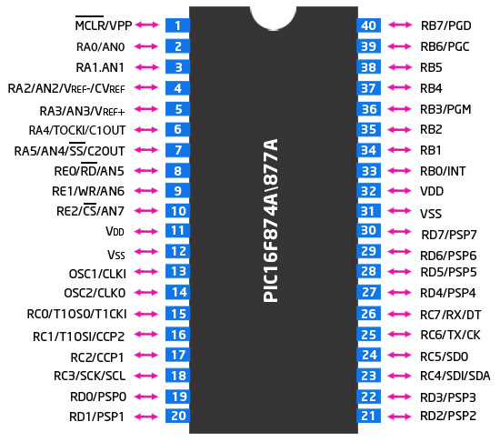

Fig- 2.18 : Pinout of Pic16f877a [ [https://microcontrollerslab.com/](https://microcontrollerslab.com/pic16f877a-introduction-features/) ]

**PIN 1 - MCLR:** The first pin is the master clear pin of this IC. It resets the microcontroller and is active low, meaning that it should constantly be given a voltage of 5V and if 0 V are given then the controller is reset. Resetting the controller will bring it back to the first line of the program that has been burned into the IC. A push button and a resistor is connected to the pin. The pin is already being supplied by constant 5V. When we want to reset the IC we just have to push the button which will bring the MCLR pin to 0 potential thereby resetting the controller.

**PIN 2- RA0/AN0 :** PORTA consists of 6 pins, from pin 2 to pin 7, all of these are bidirectional input/output pins. Pin 2 is the first pin of this port. This pin can also be used as an analog pin AN0. It is built in [analog to digital converter](https://microcontrollerslab.com/analog-to-digital-adc-converter-working/).

**PIN 3 - RA1/AN1 :** This can be the analog input 1.

**PIN 4 – RA2/AN2/Vref** : It can also act as the analog input2. Or negative analog reference voltage can be given to it.

**PIN 5 – RA3/AN3/Vref+ :** It can act as the analog input 3. Or can act as the analog positive reference voltage.

**PIN 6 – RA0/T0CKI** : To timer0 this pin can act as the clock input pin, the type of output is open drain.

**PIN 7 – RA5/SS/AN4 :** This can be the analog input 4. There is synchronous serial port in the controller also and this pin can be used as the slave select for that port.

**PIN 8 – RE0/RD/AN5 :**PORTE starts from pin 8 to pin 10 and this is also a bidirectional input output port. It can be the analog input 5 or for parallel slave port it can act as a ‘read control’ pin which will be active low.

**PIN 9 – RE1/WR/AN6 :** It can be the analog input 6. And for the parallel slave port it can act as the ‘write control’ which will be active low.

**PIN 10 – RE2/CS/A7 :** It can be the analog input 7, or for the parallel slave port it can act as the ‘control select’ which will also be active low just like read and write control pins.

**PIN 11,32 – VDD :** These two pins are the positive supply for the input/output and logic pins. Both of them should be connected to 5V.

**PIN 12, 31 – VSS :** These pins are the ground reference for input/output and logic pins. They should be connected to 0 potential.

**PIN 13 – OSC1/CLKIN :** This is the oscillator input or the external clock input pin.

**PIN 14 – OSC2/CLKOUT :**This is the oscillator output pin. A crystal resonator is connected between pin 13 and 14 to provide external clock to the microcontroller. ¼ of the frequency of OSC1 is outputted by OSC2 in case of RC mode. This indicates the instruction cycle rate.

**PIN 15 – RC0/T1OCO/T1CKI :** PORTC consists of 8 pins. It is also a bidirectional input output port. Of them, pin 15 is the first. It can be the clock input of timer 1 or the oscillator output of timer2

**PIN 16 – RC1/T1OSI/CCP2 :** It can be the oscillator input of timer 1 or the capture 2 input/compare 2 output/ PWM 2 output.

**PIN 17 – RC2/CCP1** : It can be the capture 1 input/ compare 1 output/ PWM 1 output.

**PIN 18: RC3/SCK/SCL:**It can be the output for SPI or I2C modes and can be the input/output for synchronous serial clock.

**PIN 23: RC4/SDI/SDA:**It can be the SPI data in pin. Or in I2C mode it can be data input/output pin.

**PIN 24: RC5/SDO:**It can be the data out of SPI in the SPI mode.

**PIN 25: RC6/TX/CK:**It can be the synchronous clock or USART Asynchronous transmit pin.

**PIN 26: RC7/RX/DT:**It can be the synchronous data pin or the USART receive pin.

**PIN 19,20,21,22,27,28,29,30:**All of these pins belong to PORTD which is again a bidirectional input and output port. When the microprocessor bus is to be interfaced, it can act as the parallel slave port.

**PIN 33-40: PORT B:**All these pins belong to PORTB. Out of which RB0 can be used as the external interrupt pin and RB6 and RB7 can be used as in-circuit debugger pins.

**2.12.4 : FEATURE OF PIC16F877A**

Like all other microcontroller, PIC16F877A also provide built-in useful features as mentioned in this list:

**Analog to digital converter module :**It has 8 bit ADC module which consists of 8 channels.  We can use 8 analog sensors with this microcontroller.

**Timers**: It provides three timers timer0, timer1 and timer2.  All these timers can be used either in timer mode or in counter mode.  These timers are used to generate delays, pulse width modulation, counting external events and timer interrupts. TIMER0 is a 8 bit timer and it can operate with internal or external clock frequency. When we use Timer0 in timer mode, we usually operate it with internal frequency and in counter mode, we trigger it with external clock source.  Similarly, TIMER1 is a 16-bit timer and it can also operate in both modes. TIMER2 is also of 8-bit. It is used with PWM as a time base for CCP module.

**EEPROM :**It also has built-in Electrically erasable read only memory 256 x 8 bytes which can used to store data permanently even if the microcontroller is switched off, data will remain there.  It is usually used with [**electronics lock**](https://microcontrollerslab.com/electronic-lock-pic-microcontroller/)related projects.

**PWM modules :**It also provide 2 CCP modules. CCP stands for capture compare PWM modules. We can easily generate two PWM signals with this microcontroller. The maximum resolution it supports is 10 bits. you can read[**PWM using PIC16F877A microcontroller tutorial**](https://microcontrollerslab.com/pwm-using-pic16f877a-microcontroller/) for more information and programming.

**Serial or UART communication pins** : It support one UART channel. UART pins are used for serial communication between digital devices. RC7 pin is a transmitter or RX pin which is pin number 26. RC6 is a receiver or Tx pin which is pin number 25. For additional details, check this complete guide on [serial communication using pic16f877a microcontroller](https://microcontrollerslab.com/serial-communication-using-pic16f877a-microcontroller/).

**I2C Communication** : PIC16F877A also support I2C communication and its has one module for I2C communication.  Pin#18/RC3 and 23/RC4 are **SCL**and **SDA**pins respectively. SCL is a serial clock line and SDA is serial data line.  [I2C communication tutorial](https://microcontrollerslab.com/i2c-communication-pic-microcontroller/) will help you understand further.

**Interrupts** : Interrupts have wonderful applications in embedded systems field. If you don’t know about interrupts, I suggest you to get complete understanding about them, you will not get command on embedded programming them. PIC16F877A microcontroller provides 8 types of interrupts namley; External interrupts, timer interrupts, PORT state change interrupts, UART  interrupt, I2C, PWM interrupts. you can read this guide on [pic microcontroller interrupts](https://microcontrollerslab.com/how-use-pic-microcontroller-timers-interrupt/) for additional information.

**Comparator module** : It has a comparator module which composed of two comparators. They are used for comparison of analog signal similar to comparators in electronics circuits.  Input pins for these comparators are RA0, RA1, RA2 and RA3 and output can measured through RA4 and RA5.

**Watchdog timer** : WDT is a on chip separate oscillator which runs freely. It is a separate oscillator from OSC1/CLKI.  WDT will also work even if the device is in sleep mode.  It is used to wake up device from sleep mode and also used to generate watchdog timer reset.

**Sleep mode** : PIC16F877A also provide sleep mode operation. In this mode, device operates at very low power. All peripherals draws minimum amount of current. Wake up from sleep mode from interrupts resources like timer1 interrupt, uart interrupt, EEPROM write completion operation  and many others.

**Brown out detection** : It also has a brown out detection circuit which detects the significant drop in power supply voltage. If supply voltage drop from a certain limit, it will generate a interrupt signals.  This configuration bit (BODEN) is used to disable or enable this circuitry.

**Brown out reset** : This option reset the device upon detection of brown out interrupt signal from BODEN signal. if supply voltage goes below threshold for more than 100 micro seconds,Programmable code protection, **Brown out reset**will occur and device will remain reset until the voltage raise to its nominal value.  Device checks for voltage after every 72ms.

Some other momentous features are listed below :

* Power on Reset
* Multiple oscillator group
* In-Circuit Debugger
* In-Circuit Serial programming
* Low voltage ICSP programming

**CHEPTER - 3**

**DESCRIPTION OF THE SYSTEM**

**3.1 SCHEMATRIC DESCRIPTION**

First of all, we were taking the environment temperature using a temperature sensor LM-35 . We were used four sensor for finding four different places temperature of the poultry farm such that we did catch the approximate temperature of the poultry farm. Then we calculated average temperature of those four temperature values. We were select two threshold values using two button as button-1 and button-2. Button-1 was used to increase minimum/maximum threshold value and Button-2 was used to decreased the minimum/maximum threshold value. With respect to the average temperature and two threshold, the objects will shift on into off or off into on. The objects can be fans, lights, motors, generator, alarm, air conditioner etc.

The whole system information was displayed on the LCD ( 16 X 2 ) display. For showing the information of the system, we were use three different stage. For changing the stage , We used a button called button-3. The stages are discuss below.

**Stage-1:** In stage-1, we were showing the maximum (Max) and minimum (Min) threshold values lying on first row. And the calculated average temperature (Temp) value was shown in the second row. As given the figure. If we want to change threshold value ,we will change the stage pressed by button-3 and hold on exact 3second. After 3 second the stage was changed and gone to second stage.

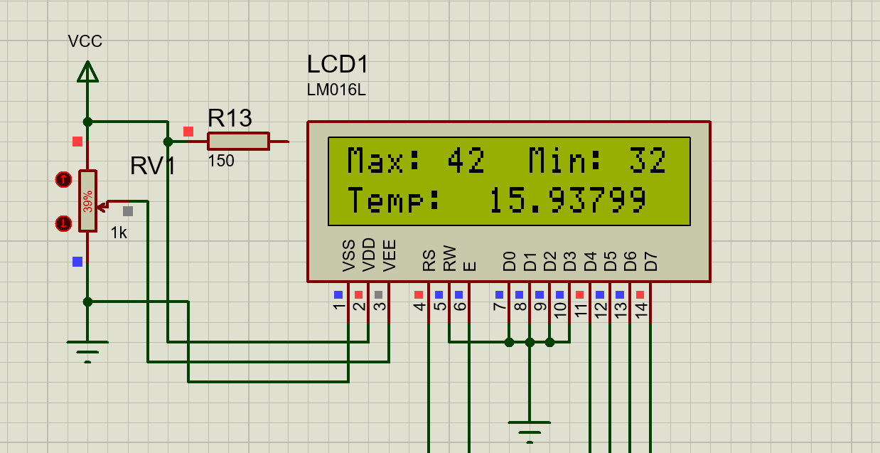

Fig- 3.1 : showing max, min and temp value on LCD display

**Stage-2:** In stage-2, we were setting the minimum threshold value by clicking button button-1 and button-2. If we clicked button-1 , the minimum threshold value was increased one by one. If we clicked button-2 , the minimum threshold value was decreased one by one. If we want to change the maximum threshold value, we would be changed the stage to press the button-3 and hold on exact 3 second. After 3 second the stage was changed and gone to third stage.

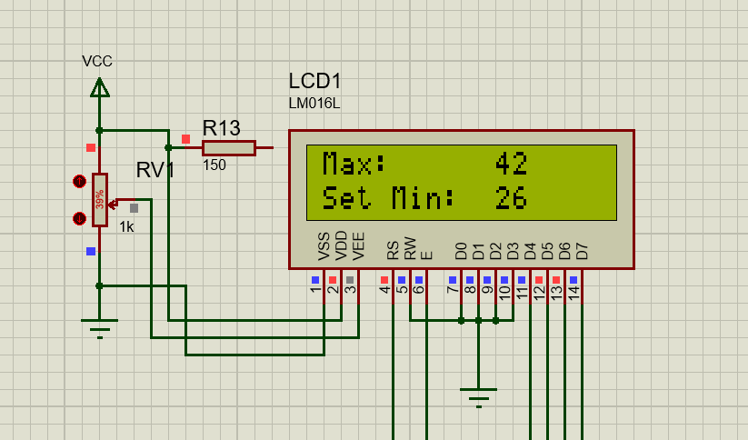

Fig- 3.2 : set minimum threshold value

**Stage-3:** In this stage, we were setting the maximum threshold value by clicking button button-1 and button-2. If we clicked button-1 , the maximum threshold value was increased one by one. If we clicked button-2 , the maximum threshold value was decreased one by one. we would be changed the stage to press the button-3 and hold on exact 3 second. After 3 second the stage was changed and gone to fourth stage.

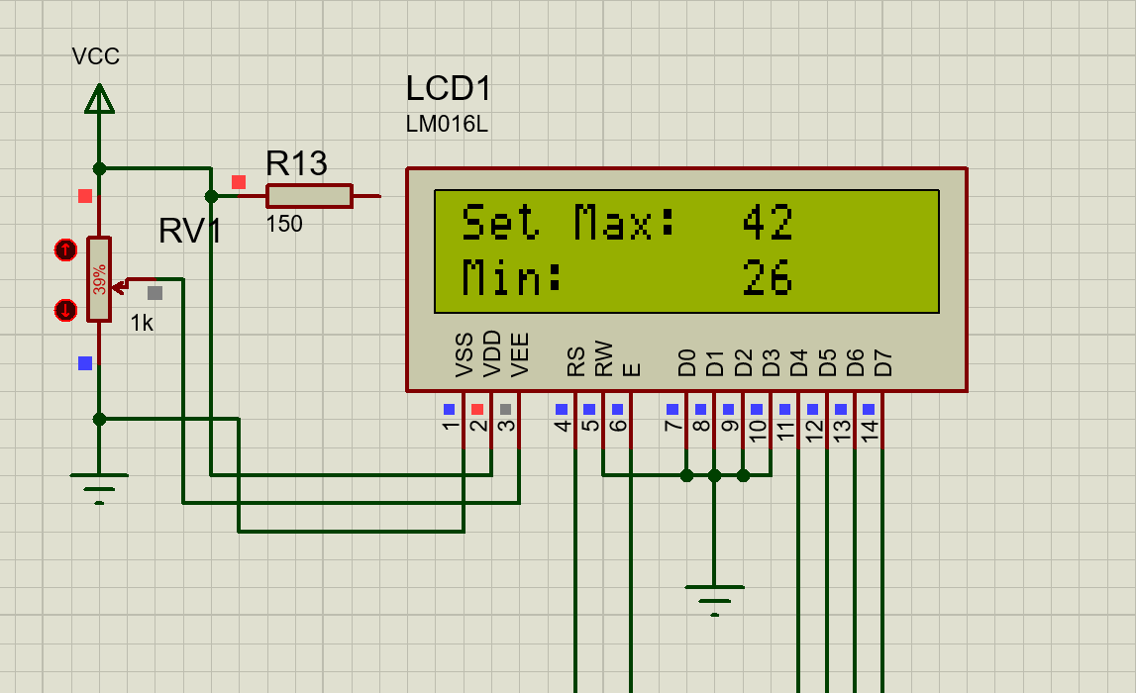

Fig- 3.3 : Set maximum threshold value

**Stage-4 :** In this stage, the four temperature sensor LM35 values were displayed. For this case , we understood which sensor was giving a exact room temperature and which sensor was damaged. We were showing s1, s2, s3, s4 to indicate sensor-1, sensor-2, sensor-3 and sensor-4 respectively. Then we pressed and hold on 3-second the button -3.the program stage was return back to the satge-1. And changed the threshold value then relay act with respect to this value.

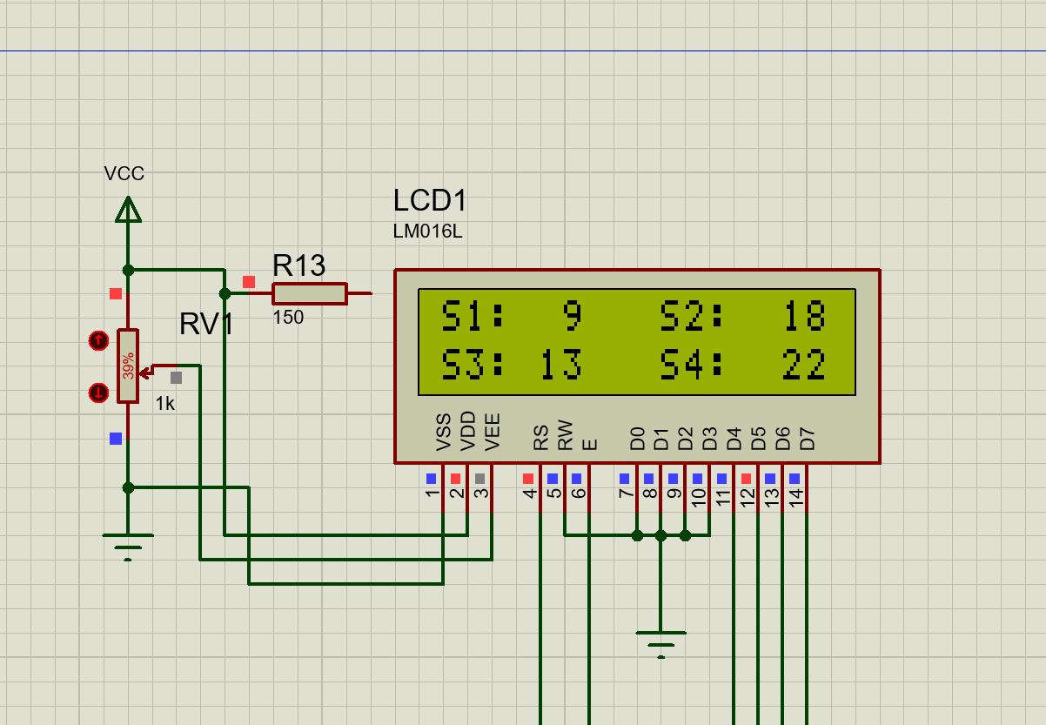

Fig- 3.4 : Displaying four input temperature value

**3.2: CIRCUIT DIAGRAM**

The circuit diagram is arranged on the proteus-8 professional software. All the components were available in that software. All components were well suit such as microcontroller clock frequency is 8MHz. Crystal oscillator clock frequency 8MHz, capacitor 22pF etc, The block diagram of this system is shown below.

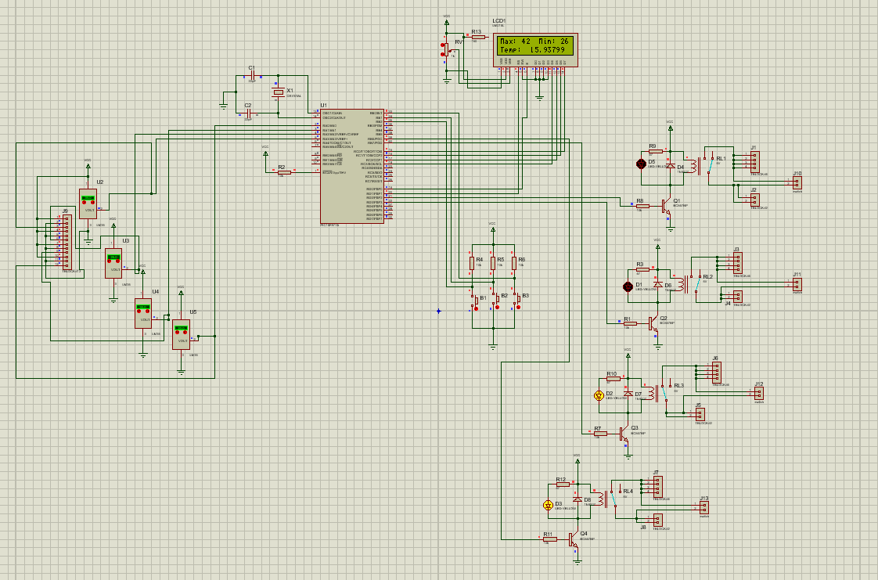

Fig- 3.5 : Circuit diagram

**3.3: ALGORITHM ( Pseudocode )**

|  |
| --- |
| Declaration part;  Set microcontroller pin to set lcd display pin;  Main function() {  Clear LCD display;  Set input / output port with objects;  Set constant value into EEPROM;    While loop (1){  If(mode==0){  First_Layout();  Decision making temperature was where;  Stage change;  }  If(mode==1){  LCD_display();  Set minimum threshold value;  DEC();  INC();  Stage change;  }  If(mode==2){  LCD_display();  Set maximum threshold value;  DEC();  INC();  Stage change;  }  If(mode==3){  All sensor value is displayed on the lcd display;  Stage change;  }  }  }  First Layout(){  Read all sensor value;  Measure average temperature;  Display on the LCD display;  }  LCD_display(){  Display minimum threshold value;  Display maximum threshold value;  }  DEC(){  Decreased the value;  And return;  }  INC(){  Increase the value;  And return;  } |

**3.4 : PHYSICAL CONNECTION ARRANGEMENT**

All the components are connected in order to the following circuit diagram.

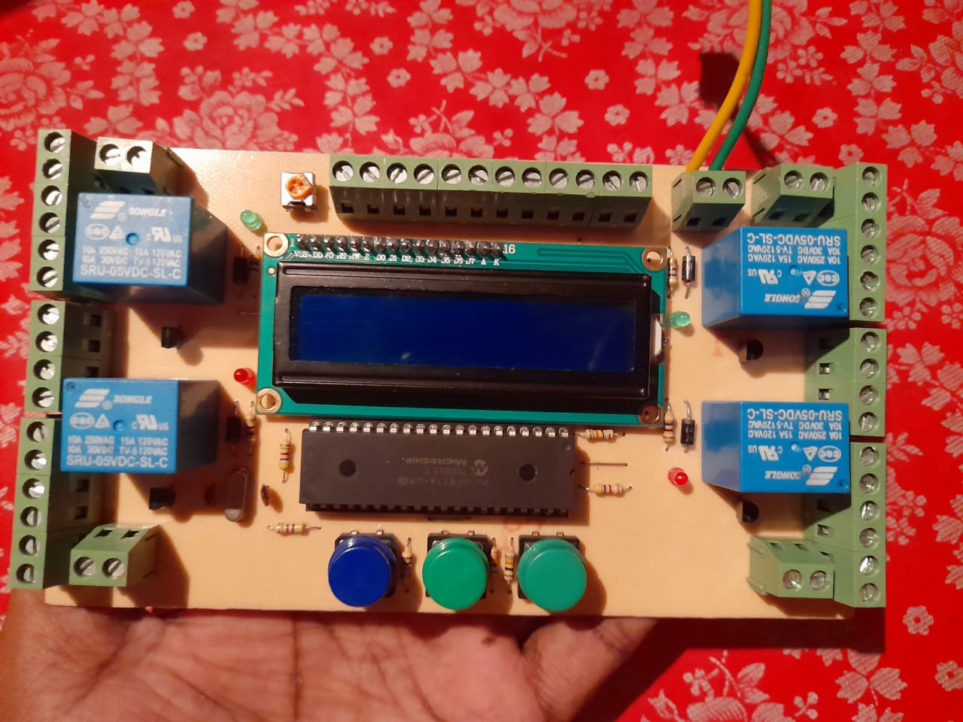

Fig- 3.6 : Physical Connection of poultry farm automation system.

**CHEPTER 4**

**RESULT AND DISCUSSION**

**4.1 : CONCLUTION**

One of the primary objectives of an engineer is to endeavor to deliver the best product or the most efficient services at the lowest cost to the end user. The system has being tested and was found to meet the expected results. The aim of this work was to design and construct a automation system in which the objects such as ( Light, Fans, Motor, Alarm, etc) were automatically on/ off with respect to poultry farm temperature and the system had thus accomplished that. The LM35 temperature sensor received the room temperature and PIC16F877A microcontroller decided to the objects would be either on or off depending on the threshold value . Note that, the two threshold values were preselected. The system has been implemented on a printed circuit board (PCB) .

**4.2 : RECOMMENDATION :**

1. Since we used LM35 as a temperature sensor should be place it dry place because of it is not waterproof . Or we used a container for keeping LM35 which was waterproof.
2. The PIC16F877A microcontroller works at range 2.0V to 5.5V , so that supply voltage keep in this range.
3. It is important that the physical circuit would be place dry place. It is mandatory that there was no water connected with it. Because water behaves like a conductor. So avoid short circuit , it is mandatory to keep dry place.

**4.3 : FUTURE WORK :**

1. We will control a motor with respect to the tank water . When the tank water is full, the motor will be automatically off and when the tank water is empty, the motor will be automatically on.
2. We will control conveyor belt for giving food for poultry and remove the poultry waste with respect to time .
3. We will also supply water for poultry as automatically.

**REFERENCES**

[ 1 ] Wariston Fernando Pereira, Leonardo da Silva Fonseca, Fernando Ferrari Putti, Bruno César Góes, Luciana de Paula Naves, “Environmental monitoring in a poultry farm using an instrument developed with the internet of things concept,Computers and Electronics in Agriculture”,Volume 170,2020, 105257, ISSN 0168-1699.

[ 2 ] M. Laanen, D. Maes, C. Hendriksen, P. Gelaude, S. De Vliegher, Y. Rosseel, J. Dewulf. “Pig, cattle and poultry farmers with a known interest in research have comparable perspectives on disease prevention and on-farm biosecurity”, Preventive Veterinary Medicine,Volume 115, Issues 1–2,2014,Pages 1-9,ISSN 0167-5877.

[ 3 ] Sparagano, O. *et al.* (2009). Prevalence and key figures for the poultry red mite *Dermanyssus gallinae* infections in poultry farm systems. In: Sparagano, O.A.E. (eds) Control of Poultry Mites (Dermanyssus). Springer, Dordrecht. <https://doi.org/10.1007/978-90-481-2731-3_2>.

[ 4 ] G. A. Choukidar and N. A. Dawande, "Smart Poultry Farm Automation and Monitoring System," 2017 International Conference on Computing, Communication, Control and Automation (ICCUBEA), 2017, pp. 1-5, doi: 10.1109/ICCUBEA.2017.8463953.

[ 5 ] M. M. Islam, S. Sourov Tonmoy, S. Quayum, A. R. Sarker, S. Umme Hani and M. A. Mannan, "Smart Poultry Farm Incorporating GSM and IoT," 2019 International Conference on Robotics,Electrical and Signal Processing Techniques (ICREST), 2019, pp. 277-280, doi: 10.1109/ICREST.2019.8644300.

[ 6 ] H. Wentian and L. Jinping, "Design of the Temperature Control System Based on AT89S51," 2010 International Forum on Information Technology and Applications, 2010, pp. 63-66, doi: 10.1109/IFITA.2010.209.

[7 ] Oyebola, Blessed and Toluwani, Odueso, LM35 Based Digital Room Temperature Meter: A Simple Demonstration (October 15, 2017). Equatorial Journal of Computational and Theoretical Science, 2(1), Available at SSRN: <https://ssrn.com/abstract=3053601>.

[ 8 ] Ramesh Saha, Biswas, S., Sarmah, S. *et al.* A Working Prototype Using DS18B20 Temperature Sensor and Arduino for Health Monitoring. *SN COMPUT. SCI.* **2**, 33 (2021). <https://doi.org/10.1007/s42979-020-00434-2>.

[ 9 ] Hidayatullah, S., 2009. Design by Room Temperature Gauge Lm35 Temperature Sensor Using At89s51 Microcontroller. *Jurnal Sistem Komputer STMIK Jakarta STI&K*, p.219079.

[ 10 ] Antonie, N., Borcoşi, I. and Cozma, V., 2011. ACQUISITION SYSTEM FOR TEMPERATURE MONITORING AND CONTROL IN TWO CHAMBERS MADE USING PIC16F877A MICROCONTROLLER. *Annals of'Constantin Brancusi'University of Targu-Jiu. Engineering Series*, (1).

[ 11 ] Adamu Murtala Zungeru, Mmoloki Mangwala, Joseph Chuma, Baboloki Gaebolae, Bokamoso Basutli,”Design and simulation of an automatic room heater control system”,Heliyon,Volume 4, Issue 6,2018,e00655,ISSN 2405-8440, <https://doi.org/10.1016/j.heliyon.2018.e00655>.

[ 12 ] Tanveer, A., Choudhary, A., Pal, D., Gupta, R. and Husain, F., 2015. Automated farming using microcontroller and sensors. *International Journal of Scientific Research and Management Studies (IJSRMS)*, *2*(1), pp.21-30.

[ 13 ] Sinduja, K., Jenifer, S.S., Abishek, M.S. and Sivasankari, B., 2016. Automated control system for poultry farm based on embedded system. *International Research Journal of Engineering and Technology*, *3*(3), pp.620-624.